ASSIGNMENT –1

write html code to create a form with input and apply CSS on it .

CODE:

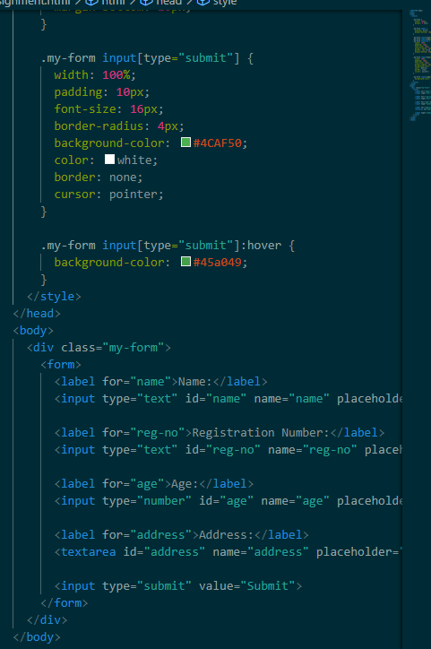



OUTPUT:

